1. **Bellingham Warehouse**

**Area:** 1,200 sqft

**Address:** 4229 Guide Meridian, Bellingham, WA 98226

**Rent:** $1,200+$240(NNN) = $1440

**Notes:** Allow us to build an office

**Advantage:** In the heart of Bellingham, have a store front which reserves the possibility retailer business in the future.

**Disadvantage:** No existing office. Space outside of the warehouse door is very small, truck may be stuck.

**Images:**

Front

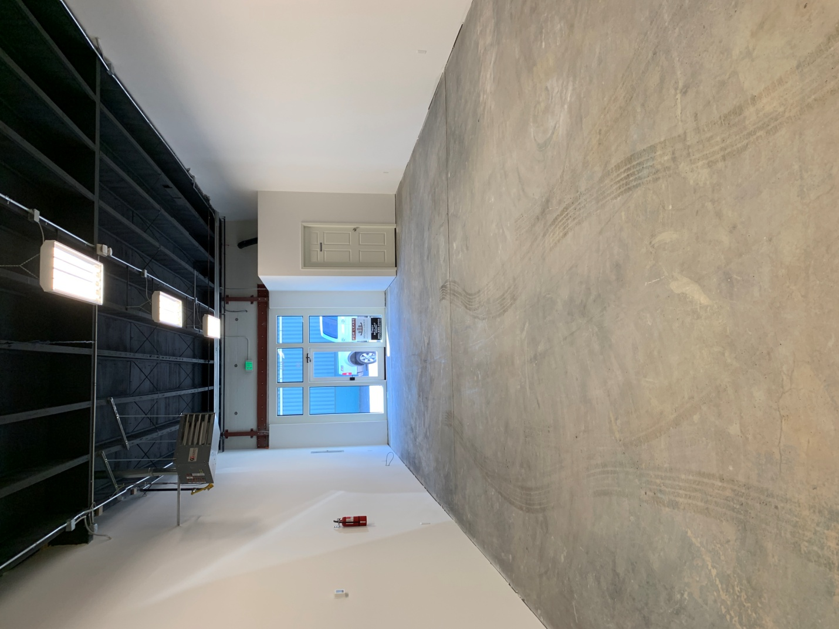

Back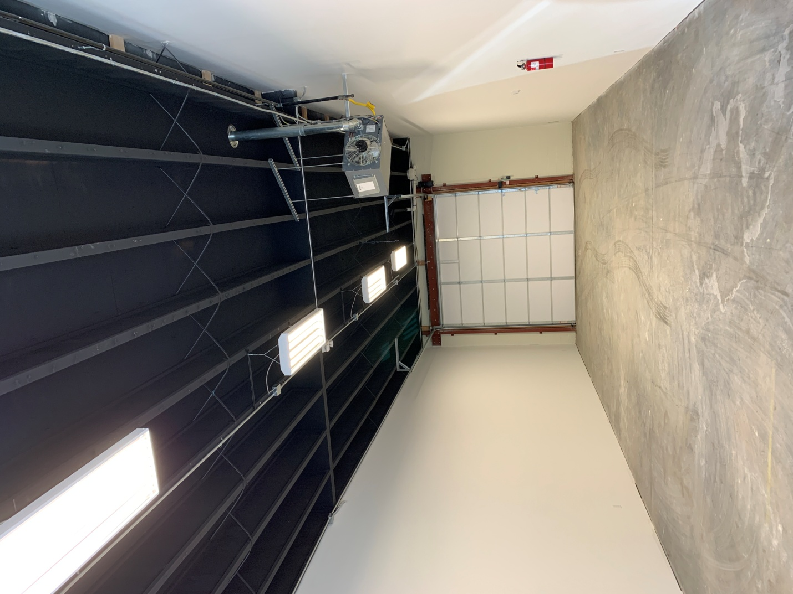

Space outside warehouse door

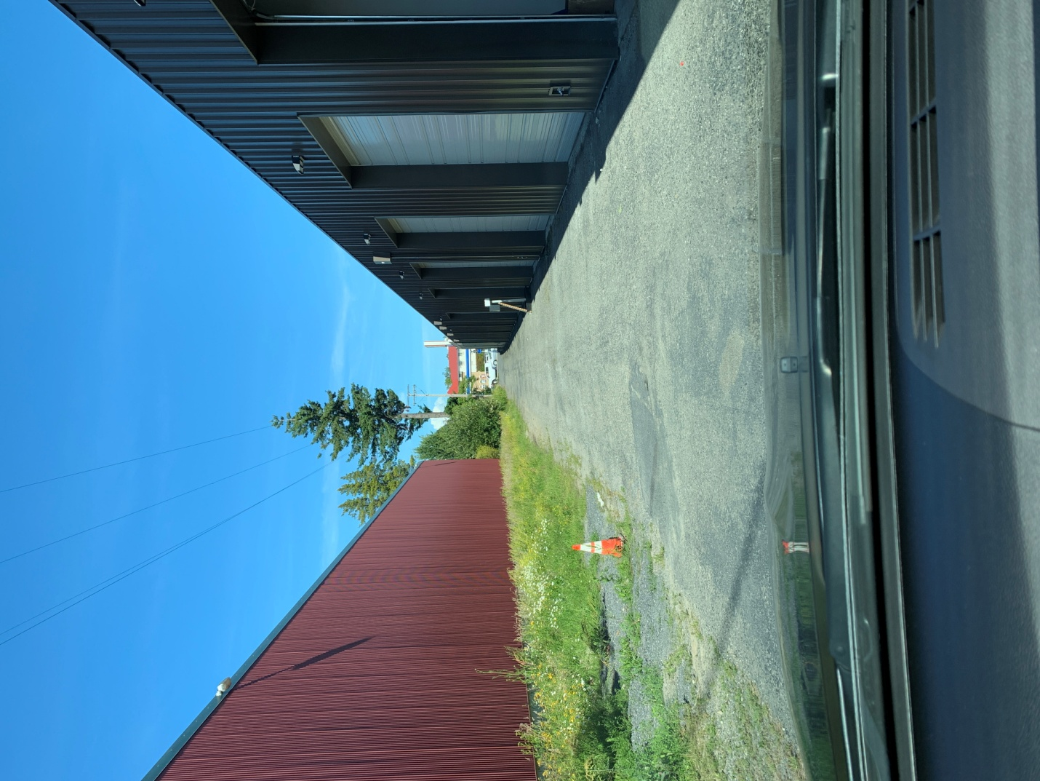

1. **Ferndale Warehouse**

**Area:** 1,500 sqft

**Address:** 6214 Portal Way, Ferndale, WA 98248

**Rent:** $1,395(one year), $1,295(5 year)

**Notes:** Office already built. Allow us to build another room if needed.

**Advantage:** Cheap. Very close to I-5 exit 263. Ready to use. Large space for trucks.

**Disadvantage:** It is in Ferndale. They do not allow retailer business.

**Images:**

Front

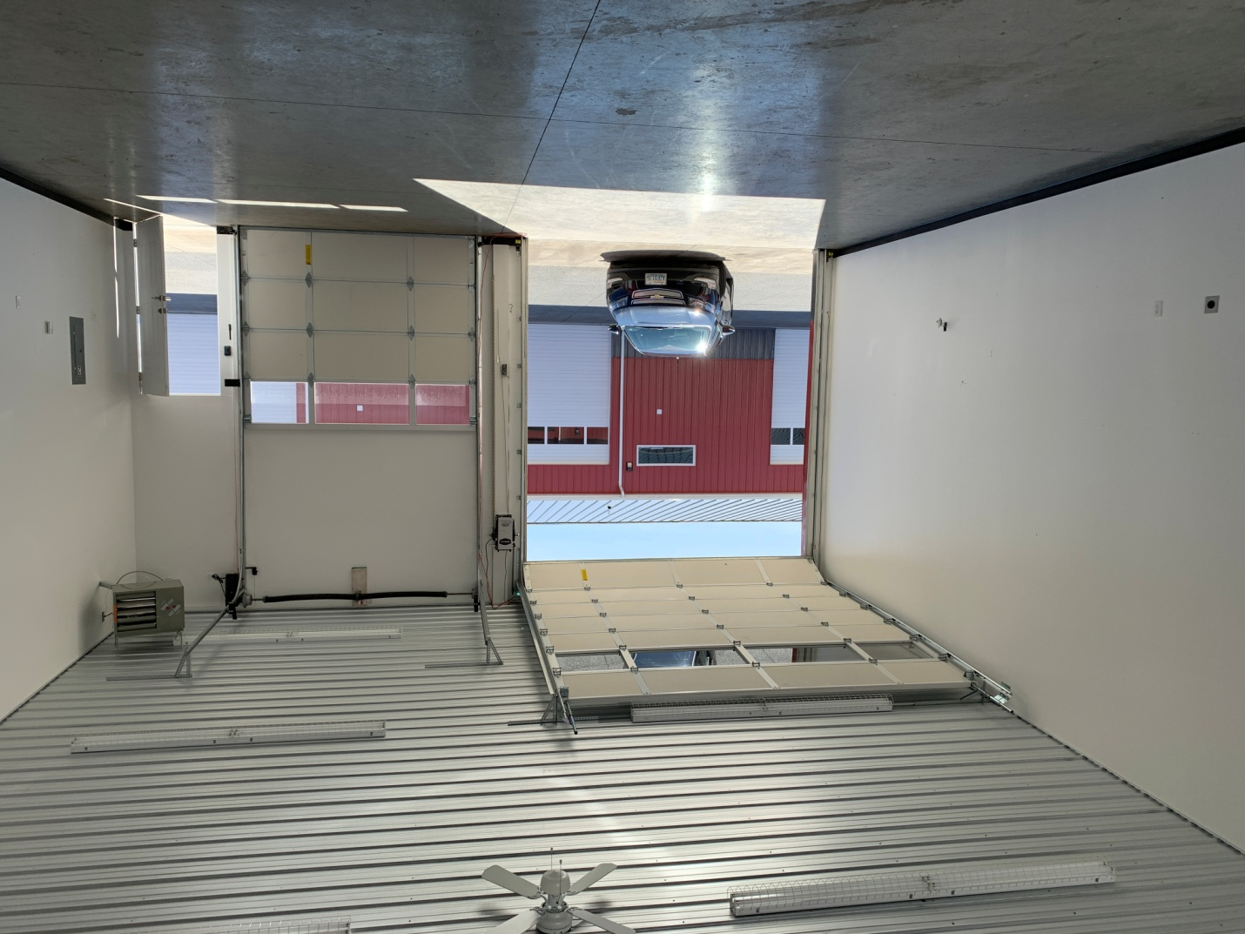

Back

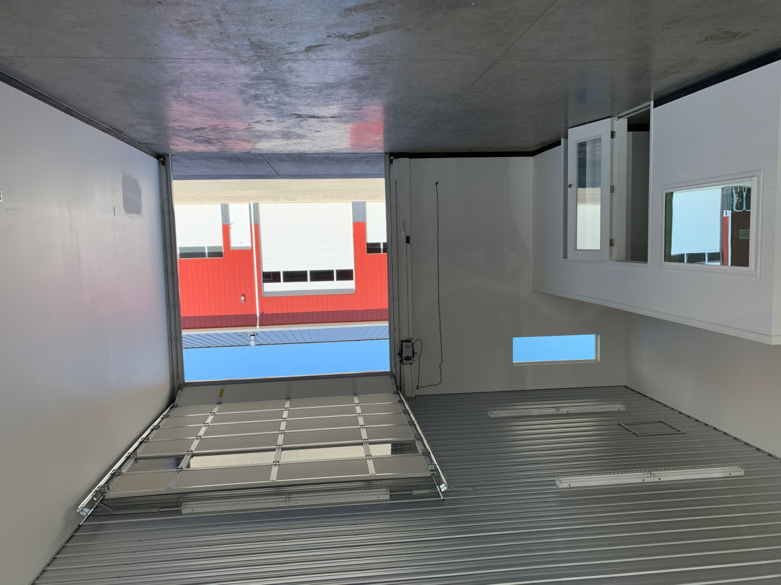

Inside

